11.96: The geometry of the 3-4-5 right triangle simplifies some of the intermediate algebra. Denote the forces on the ends of the ladders by 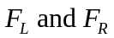(left and right). The contact forces at the ground will be vertical, since the floor is assumed to be frictionless. a) Taking torques about the right end, may be found in a similar manner, or from 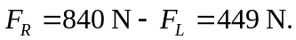 b) The tension in the rope may be found by finding the torque on each ladder, using the point A as the origin. The lever arm of the rope is 1.50 m. For the left ladder, (322 N to three figures). As a check, using the torques on the right ladder, gives the same result. c) The horizontal component of the force at A must be equal to the tension found in part (b). The vertical force must be equal in magnitude to the difference between the weight of each ladder and the force on the bottom of each ladder, 480 N−391 N = 449 N−360 N = 89 N. The magnitude of the force at A is then
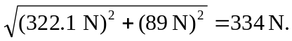
d) The easiest way to do this is to see that the added load will be distributed at the floor in such a way that Using these forces in the form for the tension found in part (b) gives
which is 937 N to three figures.

